Home Page

Headline
MARS SIGMA SOLUTIONS PVT LTD

Driving Quality. Transforming Businesses. Delivering Excellence.
Expert solutions in ISO Management Systems, Business Transformation, Third-Party Inspection, Industrial Training and Continuous Improvement.
India | Bahrain

Introduction
At Mars Sigma Solutions, we partner with organizations to strengthen quality, improve operational performance and build sustainable management systems.
With extensive industry experience across manufacturing and service sectors, we deliver practical, result-oriented solutions in ISO Management Systems, Business Transformation, Third-Party Inspection, Supplier Development and Industrial Training.
Our approach goes beyond achieving certification. We help organizations build systems that work, perform and continually improve.

Recommended action buttons
I suggest two prominent buttons:
Explore Our Services — takes visitors to the services overview.
Talk to Our Experts — opens the contact form or WhatsApp enquiry.

My suggestion for the visual design
The Home Page should feature a high-quality industrial photograph showing manufacturing operations, quality inspection or professional industrial consulting.

One important addition
“From Certification Readiness to System Sustenance — Your Partner at Every Stage of Excellence.”

Home Page – Section 2: Who We Are

WHO WE ARE

Your Trusted Partner in Quality, Compliance & Operational Excellence
Mars Sigma Solutions Pvt Ltd is a professional consulting and industrial services organization committed to helping businesses achieve excellence through effective management systems, process improvements and technical expertise.
We work closely with manufacturing and service organizations to strengthen operational performance, enhance compliance, develop people and build a culture of continual improvement.
Our expertise spans ISO Management System Consulting, Business Transformation, Third-Party Inspection, Supplier Development, Industrial Training and Management System Sustenance.
What sets us apart is our practical, industry-driven approach.
We don't just recommend solutions. We work alongside your teams to implement improvements, overcome operational challenges and develop management systems that deliver lasting value.
At Mars Sigma, our commitment goes beyond compliance — we help businesses perform better, every day.

Experience and credibility
Your current website includes four animated statistics, but the figures still need confirmation.
I suggest displaying them prominently below the introduction.

25+
Years of Industry Experience

1500+

Organizations Supported

5,000+
Professionals Trained

5+

Countries Served

Keep this section relatively short on the actual website. The strongest approach is to show the introduction, a few credibility statistics and a “Discover More About Us” link to a dedicated About Us page.

WHAT WE DO

Comprehensive Solutions for Quality, Compliance & Business Excellence
From implementing internationally recognized management systems to improving operational efficiency and ensuring product quality, Mars Sigma delivers practical solutions that help organizations achieve sustainable business excellence.
Our Six Core Services
1. ISO Management System Consulting
Build effective management systems that strengthen compliance, improve performance and prepare your organization for certification.
- ISO 9001
- IATF 16949
- ISO 14001
- ISO 45001
- ISO 27001
- AS9100
- ISO 22000
- ISO 17025
2. Management System Sustenance & Continuous Improvement
Certification is a milestone. Sustaining excellence is a commitment.
Keep your management systems effective, updated and audit-ready through structured, ongoing professional support.
- Internal Audits
- Management Reviews
- Documentation
- Corrective Actions
- Surveillance Readiness
- Continual Improvement
3. Third-Party Inspection & Quality Assurance
Protect your business from costly defects, rework and customer complaints through professional inspection and verification services.
- Incoming Inspection
- In-Process Inspection
- Final Inspection
- Pre-Dispatch Inspection
- Vendor Inspection
- Quality Manpower Deployment
4. Business Transformation & Operational Excellence
Transform business performance by improving processes, reducing waste, strengthening productivity and building a culture of excellence.
- Lean Manufacturing
- Six Sigma
- 5S
- TPM
- TQM
- Process Improvement
5. Supplier Development & Quality Improvement
Strengthen your supply chain by developing supplier capabilities, improving process controls and addressing recurring quality issues.
- Supplier Audits
- Supplier Evaluation
- Process Improvement
- Root Cause Analysis
- Corrective Action Support
6. Industrial Training & Competency Development
Develop competent professionals and high-performing teams through practical, industry-focused technical and management-system training.
- Lead Auditor Training
- Internal Auditor Training
- Automotive Core Tools
- VDA 6.3
- Six Sigma
- Lean Manufacturing

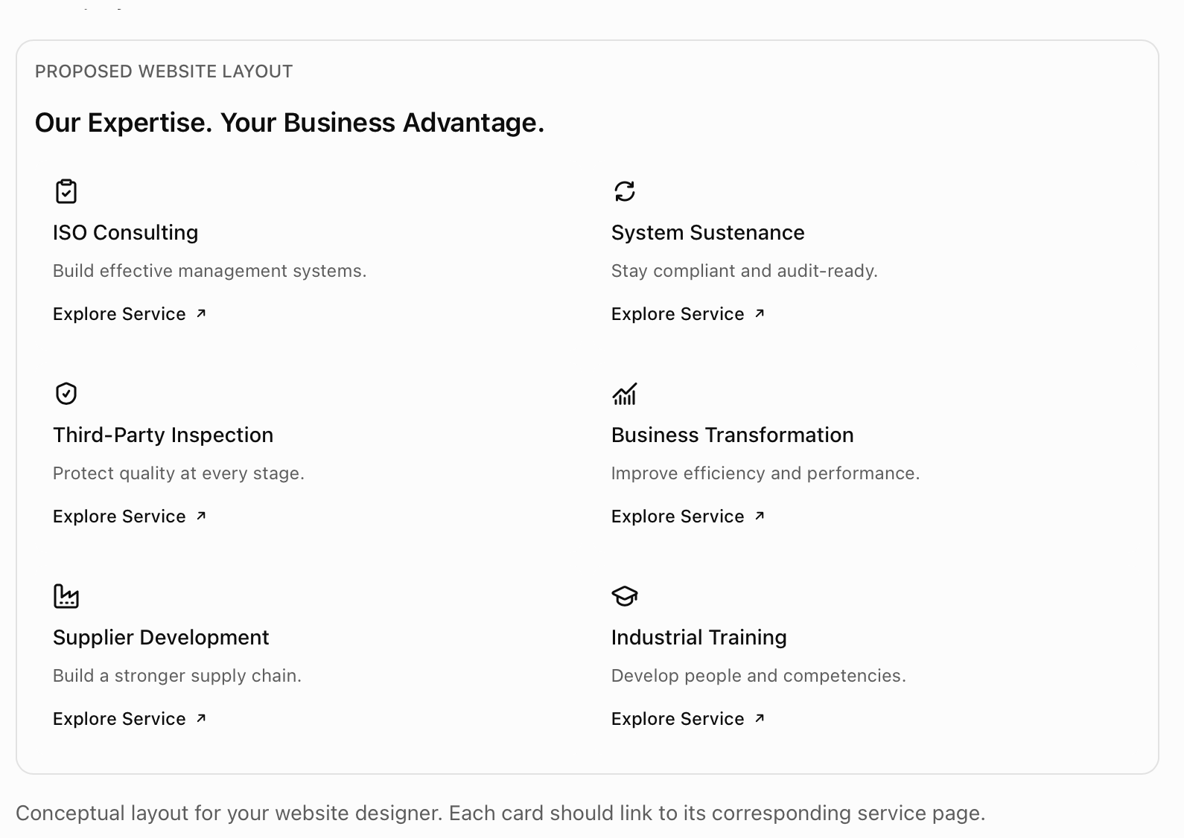

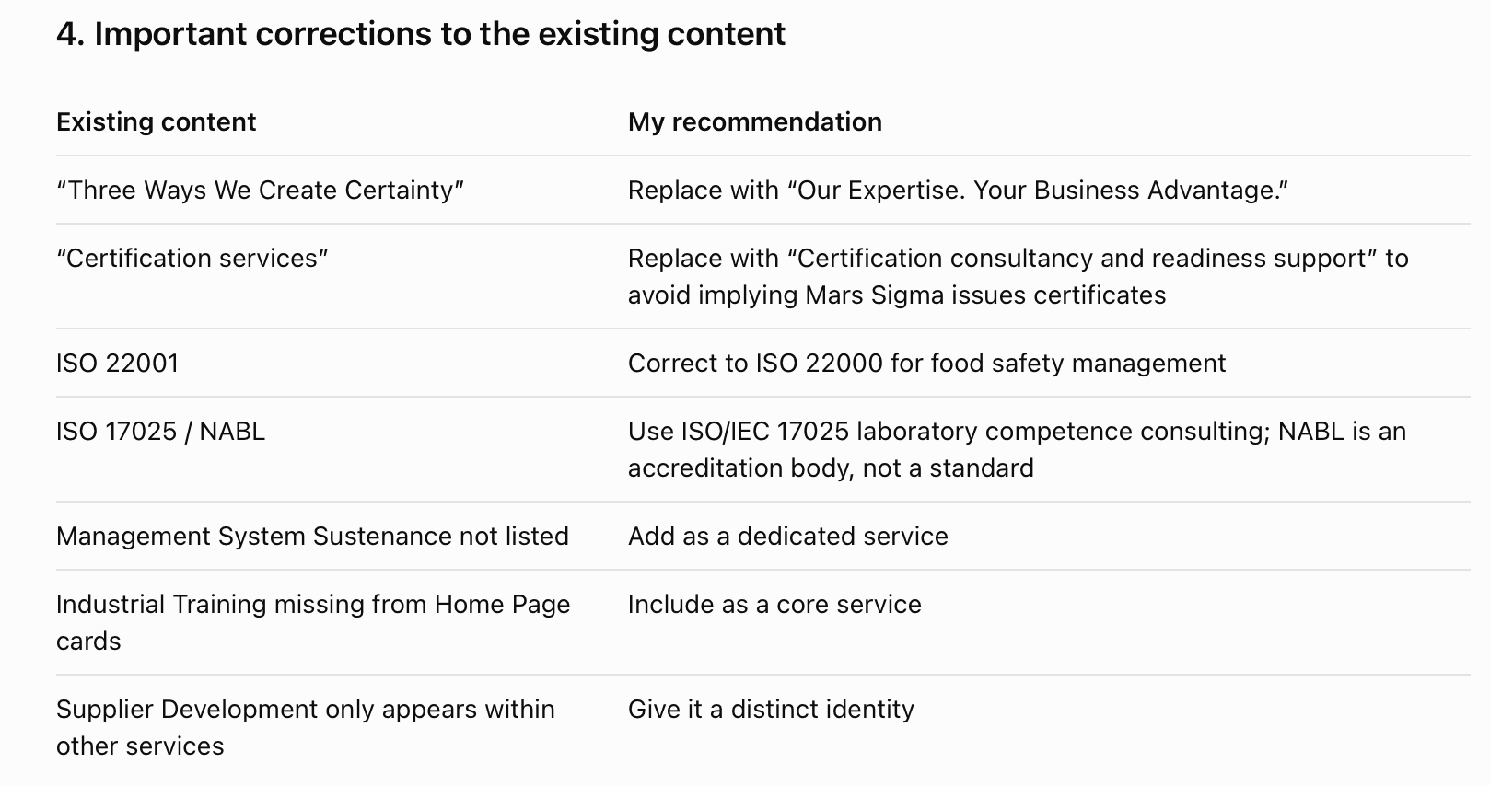

5. My strategic recommendation
I would give Management System Sustenance special emphasis because it creates an opportunity for long-term customer relationships and recurring business.
For Third-Party Inspection, I would also prominently feature Quality Manpower Deployment, given Mars Sigma's industrial inspection activities.
Finally, I suggest changing the sequence of services so that
- ISO Consulting
- Management System Sustenance,
- Third-Party Inspection,
- Business Transformation,
- Supplier Development
- Industrial Training.
My preferred headline:
“Our Expertise. Your Business Advantage.”

Home Page – Section 4: ISO 9001:2026 Transition

ISO 9001:2026 TRANSITION

ISO 9001:2026 – Is Your Organization Ready for the Next Generation of Quality Management?
The standard has evolved. Is your Quality Management System ready?
The transition to ISO 9001:2026 presents an opportunity for organizations to review their existing Quality Management Systems, strengthen risk-based thinking, enhance operational effectiveness and reinforce a culture of quality and continual improvement.
At Mars Sigma Solutions Pvt Ltd, we help organizations transition from ISO 9001:2015 to ISO 9001:2026 through a structured, practical and business-focused approach.
Our ISO 9001:2026 Transition Support
01 | Understand the Changes
Identify the revised requirements and understand their implications for your organization's existing Quality Management System.
02 | Conduct a Gap Assessment
Evaluate your current processes, documentation and practices against ISO 9001:2026 requirements.
03 | Develop a Transition Roadmap
Prepare a practical action plan with defined responsibilities, priorities and timelines.
04 | Implement Required Improvements
Update relevant processes, documentation and controls while building awareness and competence across the organization.
05 | Verify System Effectiveness
Conduct internal audits, review corrective actions and evaluate readiness for the transition audit.
06 | Sustain & Continually Improve
Maintain an effective Quality Management System through periodic reviews, performance monitoring and ongoing improvement.

Don't Just Transition. Transform the Way Quality Works.
Partner with Mars Sigma for a structured ISO 9001:2026 transition.
CTA: Book Your ISO 9001:2026 Gap Assessment

3. Recommended website design

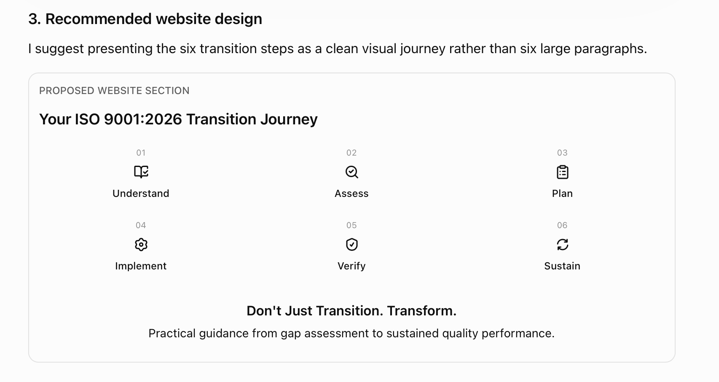4. Important corrections to the existing website

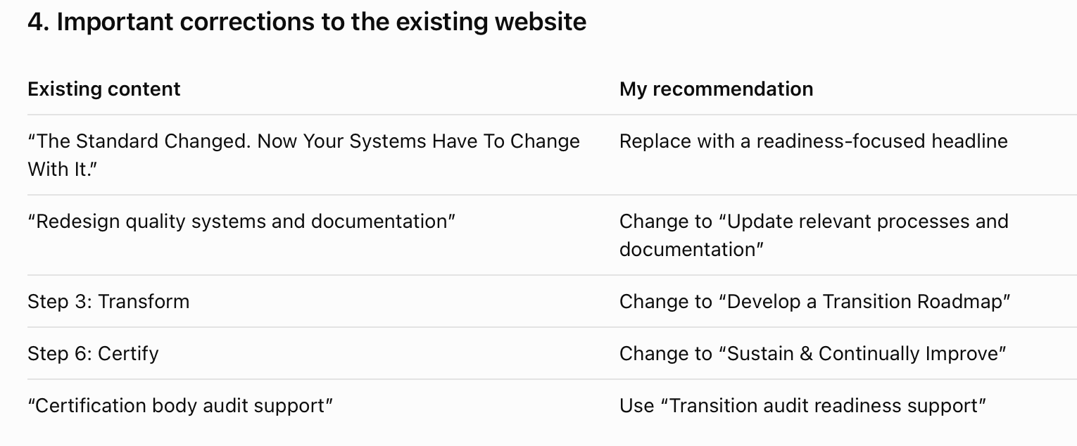
Already ISO 9001:2015 Certified?
Prepare your Quality Management System for ISO 9001:2026 with a structured gap assessment and transition action plan.
Speak to Our ISO Transition Experts
“ISO 9001:2026 – Is Your Organization Ready for the Next Generation of Quality Management?”
And make “Book Your ISO 9001:2026 Gap Assessment” the primary call to action.

WHY MARS SIGMA?

Experience That Understands Your Challenges. Expertise That Delivers Results.
At Mars Sigma Solutions, we believe that effective consulting begins with understanding your business—not simply interpreting the requirements of a standard.
Our approach combines industry experience, technical expertise and practical implementation to deliver solutions that strengthen performance, improve compliance and create lasting value.
Why Organizations Choose Mars Sigma
01 | Decades of Industry & Auditing Experience
Our founder-led approach brings extensive experience in management systems, quality auditing, manufacturing operations and business improvement.
We understand the challenges organizations face—from shop-floor quality issues to complex management-system requirements.
02 | Practical Solutions. Measurable Improvements.
We go beyond documentation and recommendations.
Our focus is on implementing practical solutions that help organizations improve processes, reduce inefficiencies, strengthen compliance and achieve meaningful operational improvements.
03 | Expertise Across Multiple Industries
From automotive and engineering manufacturing to aerospace, process industries and service organizations, we understand that every industry has unique challenges.
Our solutions are tailored to your operations, customer requirements and business objectives.
04 | From Implementation to Sustained Excellence
Our relationship does not have to end with certification readiness.
Through structured Management System Sustenance services, we support organizations with internal audits, management reviews, corrective actions, documentation and continual improvement.
05 | Integrated Quality & Industrial Solutions
Mars Sigma brings together management-system consulting, business transformation, third-party inspection, supplier development and industrial training.
This integrated approach helps organizations address both management-system and operational quality challenges.
06 | A Commitment to Your Business Success
We believe in working closely with your team, understanding your challenges and developing solutions that can be implemented effectively.
Our commitment is to build long-term relationships through professional service, technical integrity and consistent support.

We Don't Just Build Systems. We Help Businesses Perform Better.

3. How this should appear on the website
I recommend using six elegant cards with minimal text, rather than displaying the complete paragraphs on the Home Page.
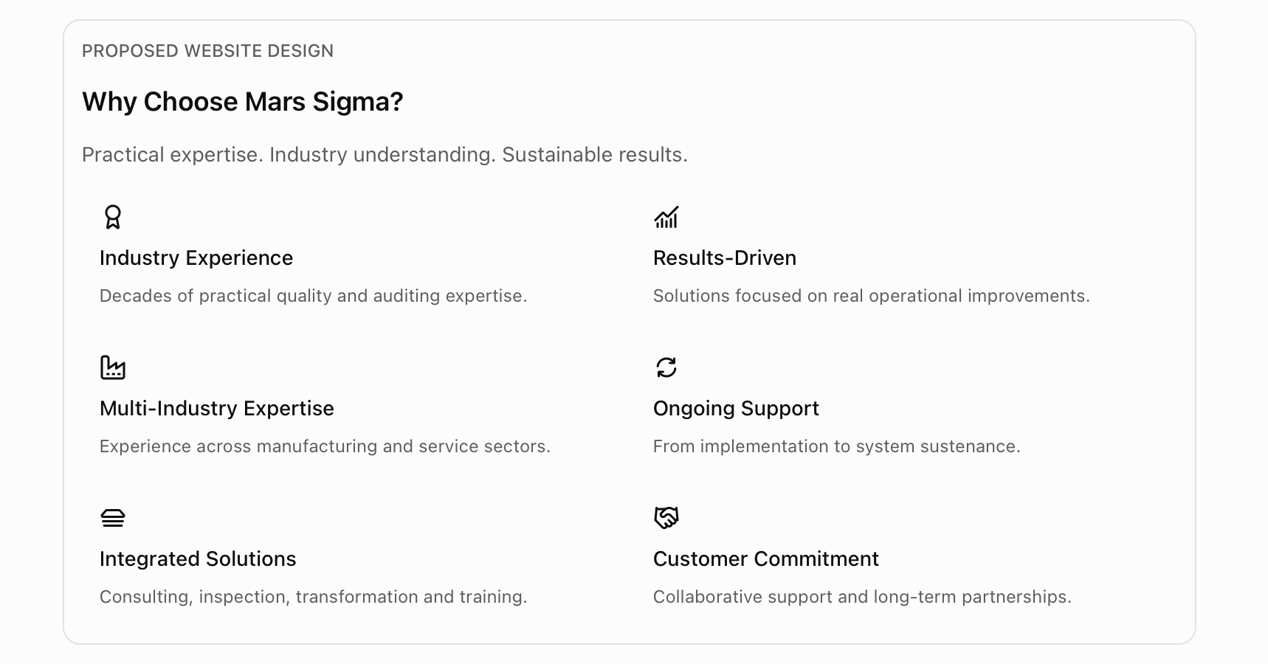

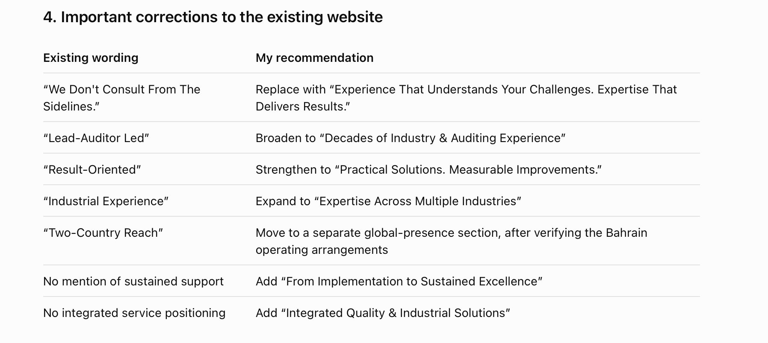Real photographs of your consulting, inspection and training activities.
- Verified industry experience and professional qualifications.
- Actual customer success stories, with permission.
- Measurable improvements from completed projects, where documented.

Section 6: Industries We Serve

INDUSTRIES WE SERVE

Industry-Specific Expertise. Business-Focused Solutions.
Every industry faces unique challenges in quality, compliance, operational efficiency and customer expectations.
At Mars Sigma Solutions, we combine industry knowledge with practical technical expertise to help organizations strengthen management systems, improve processes and achieve sustainable performance.
Our Industry Expertise
01 | Engineering & Manufacturing
Improving product quality, manufacturing efficiency and process reliability through management-system consulting, inspection services, supplier development and continuous improvement.
ISO 9001 | Lean Manufacturing | Six Sigma | Third-Party Inspection | Supplier Quality
02 | Automotive & Auto Components
Supporting automotive manufacturers and suppliers in meeting stringent quality requirements, strengthening process controls and improving supplier performance.
IATF 16949 | VDA 6.3 | APQP | PPAP | FMEA | MSA | SPC
03 | Aerospace & Precision Engineering
Supporting aerospace and precision engineering organizations in strengthening quality management, process discipline, traceability and compliance with applicable customer and industry requirements.
AS9100 | ISO 9001 | Process Audits | Supplier Quality | Inspection
04 | FMCG & Food Processing
Helping consumer goods and food-processing organizations improve operational consistency, process controls, quality management and food safety systems.
ISO 9001 | ISO 22000 | GMP | Process Improvement | Operational Excellence
05 | Information Technology & Service Organizations
Helping technology and service-based organizations establish effective management systems, strengthen information security practices and improve service delivery.
ISO/IEC 27001 | ISO 9001 | Risk Management | Internal Audits | System Sustenance
06 | Process & Industrial Sectors
Supporting chemical, pharmaceutical, energy and other process industries in strengthening operational controls, environmental management, workplace safety and continual improvement.
ISO 9001 | ISO 14001 | ISO 45001 | Process Audits | Operational Excellence

Whatever Your Industry, Quality Drives Performance.
Partner with Mars Sigma to strengthen your systems, processes and people.

Recommended website presentation
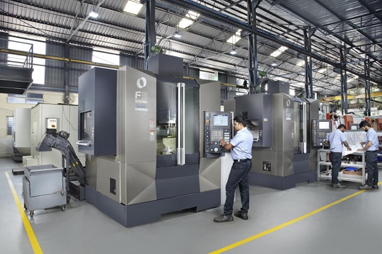
Engineering & Manufacturing
Stronger processes. Better product quality.

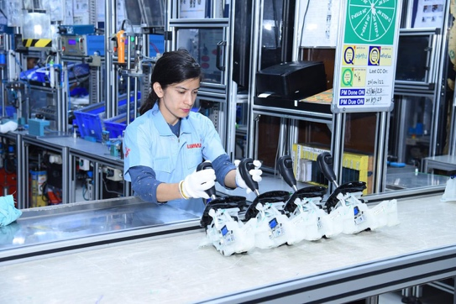
Automotive & Auto Components
Automotive quality. Supplier excellence.

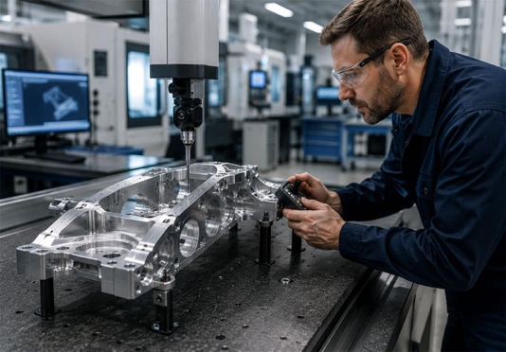
Aerospace & Precision Engineering
Precision, traceability and process control.

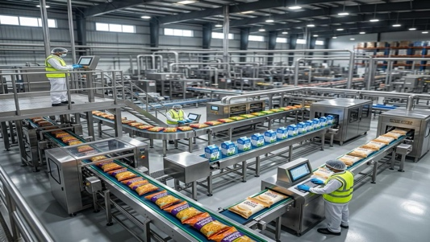
FMCG & Food Processing
Consistent quality. Reliable operations.


IT & Service Organizations
Information security. Process excellence.

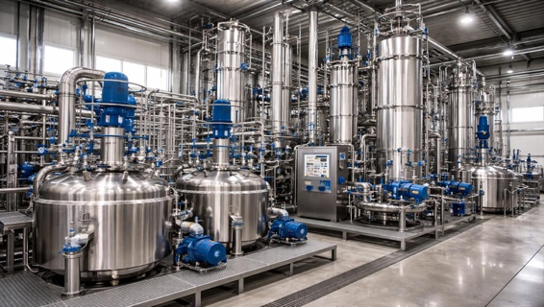
Process & Industrial Sectors
Safer operations. Stronger compliance.

Important corrections and improvements

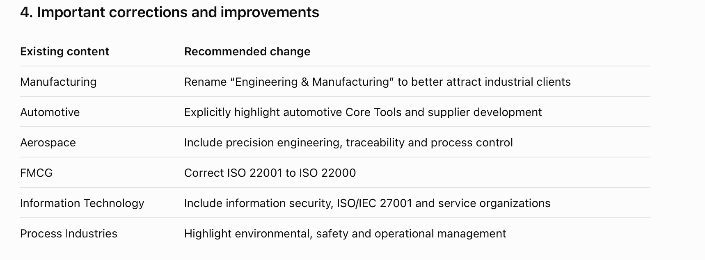
The website should also be optimized for search terms such as:
- ISO consultancy for automotive manufacturers in Chennai
- IATF 16949 implementation support
- Third-party inspection services in Tamil Nadu
- Supplier quality improvement services
- ISO 9001 management system sustenance
- ISO 27001 consultancy in Chennai

MEET OUR FOUNDER

Three Decades of Experience. One Commitment to Excellence.
Mr. Srinivasan Subramanian
Founder & Principal Consultant | Mars Sigma Solutions Pvt Ltd

With approximately three decades of professional experience in quality management, management-system auditing, industrial consulting and operational improvement, Mr. Subramanian Srinivasan brings a practical, business-focused perspective to organizational excellence.
His professional expertise spans management-system implementation, quality auditing, automotive quality requirements, Lean Manufacturing, Six Sigma and continuous improvement.
Through his leadership, Mars Sigma focuses on helping organizations move beyond procedural compliance to develop effective systems, capable teams and sustainable operational practices.
His approach is founded on a simple principle:
“Quality should not exist merely in documents or audit reports. It should be reflected in the way an organization operates, performs and continually improves.”
Mars Sigma's consulting philosophy emphasizes practical implementation, customer collaboration, technical integrity and long-term improvement.

Areas of Professional Expertise
- ISO Management Systems & Quality Auditing
- Automotive Quality Management & VDA 6.3
- Lean Manufacturing & Six Sigma
- Business Process Improvement
- Industrial Quality & Supplier Development
- Professional Training & Competency Development
A Vision Beyond Compliance
To help organizations build stronger management systems, develop capable people and achieve lasting business excellence.
The quotation is proposed brand messaging, not a verified personal quotation. It should be approved by the founder before publication.

How I recommend displaying this section

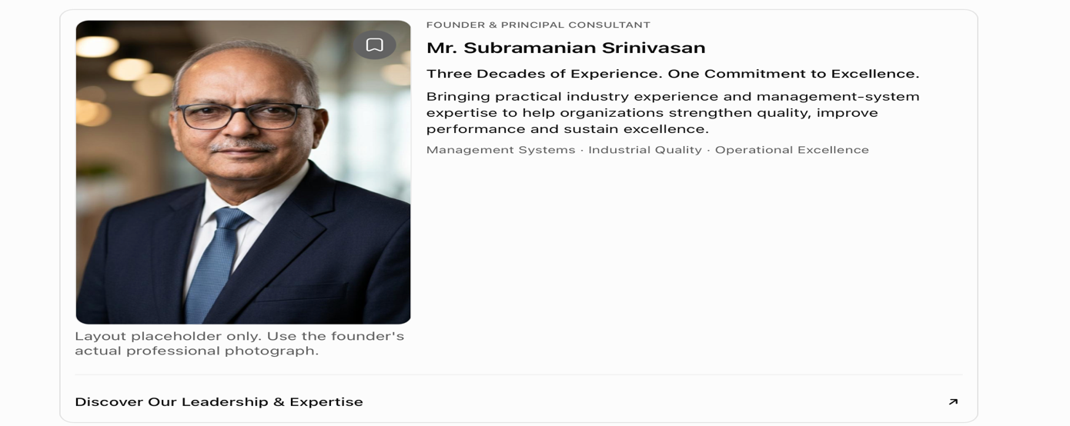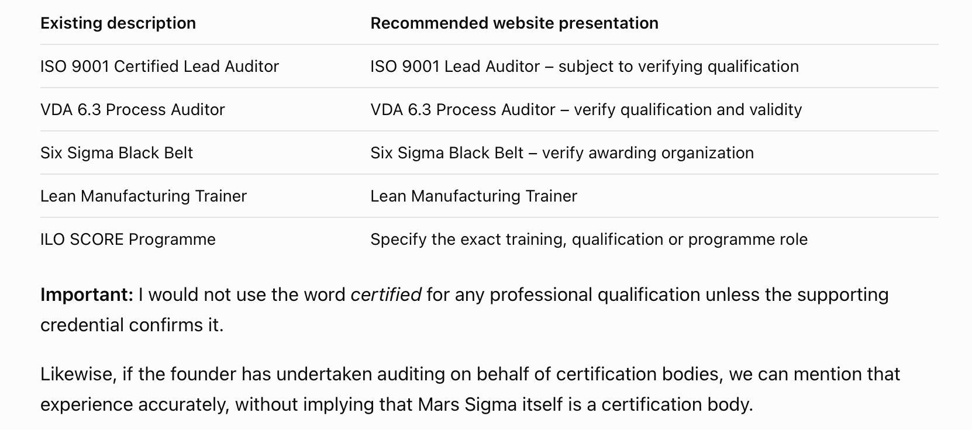

4. Professional credentials – important presentation improvements
The existing website lists several professional credentials. These should be displayed accurately and consistently.
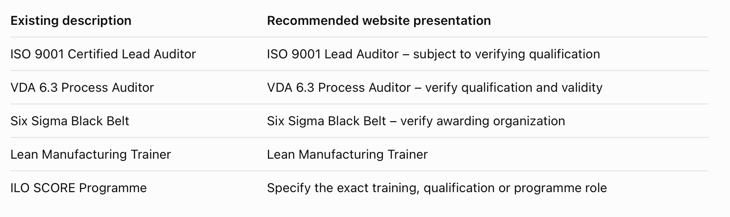

A Message from Our Founder
At Mars Sigma, we believe that quality is not achieved through certification alone. It is achieved when effective processes, competent people and a commitment to continual improvement become part of an organization's everyday operations.
Our mission is to help businesses translate management-system requirements into practical improvements that strengthen performance, enhance customer confidence and create sustainable value.
We are committed to working alongside our customers as trusted partners in their journey towards operational excellence.
Mr. Subramanian Srinivasan
Founder & Principal Consultant
Mars Sigma Solutions Pvt Ltd

Section 8: How We Work

HOW WE WORK

A Structured Approach. Practical Solutions. Sustainable Results.
At Mars Sigma Solutions, we believe that meaningful improvement begins with understanding your organization's challenges, objectives and operational realities.
Our approach combines systematic assessment, technical expertise, collaborative implementation and continuous improvement to deliver solutions that work in practice—not just on paper.
OUR SIX-STEP APPROACH
01 | Understand
We begin by understanding your business.
We engage with your leadership and operational teams to understand your objectives, existing processes, customer requirements and key challenges.
02 | Assess
Identify gaps. Discover opportunities.
Through structured assessments, process reviews and relevant audits, we identify compliance gaps, operational risks and opportunities for improvement.
03 | Design
Develop solutions that fit your organization.
We create practical action plans, management-system frameworks and improvement strategies aligned with your business needs, resources and priorities.
04 | Implement
Turn recommendations into meaningful action.
We work alongside your teams to implement agreed improvements, strengthen processes, develop competencies and embed effective management practices.
05 | Verify
Measure effectiveness. Build confidence.
We evaluate the implementation through relevant audits, performance reviews, process verification and corrective-action follow-up.
06 | Sustain
Make improvement part of everyday operations.
We support organizations in maintaining effective systems through periodic reviews, internal audits, performance monitoring and continual improvement initiatives.

Beyond Recommendations. Towards Lasting Results.
At Mars Sigma, our focus is not simply on completing an assignment—it is on helping your organization build the capability to sustain improvements.
How I recommend presenting this section
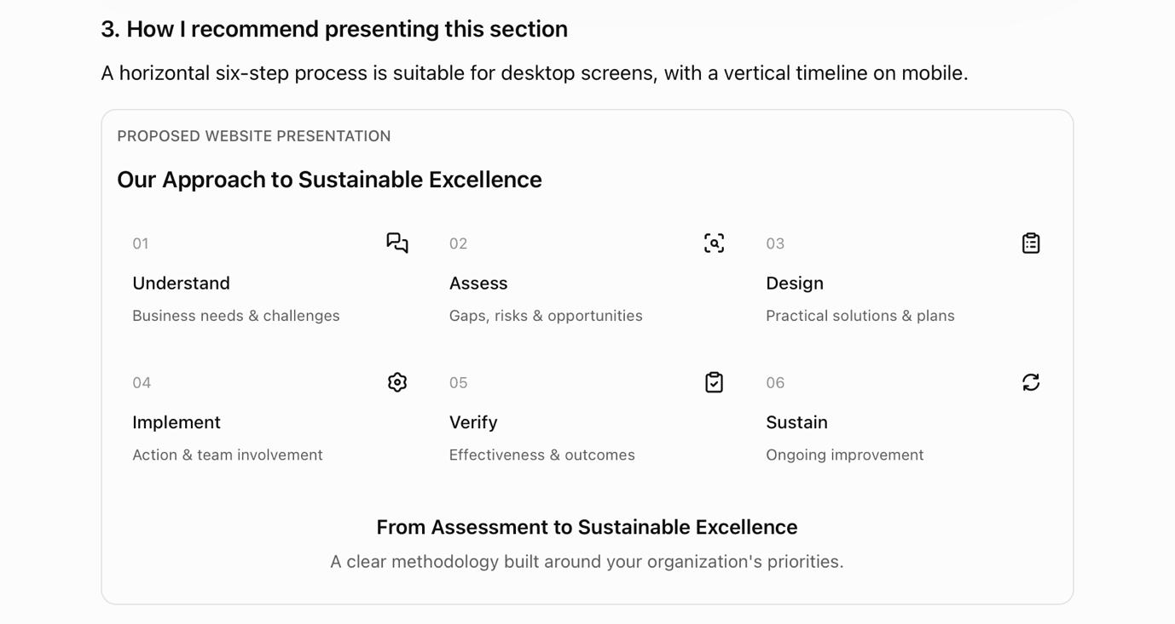
Improvements over the existing content
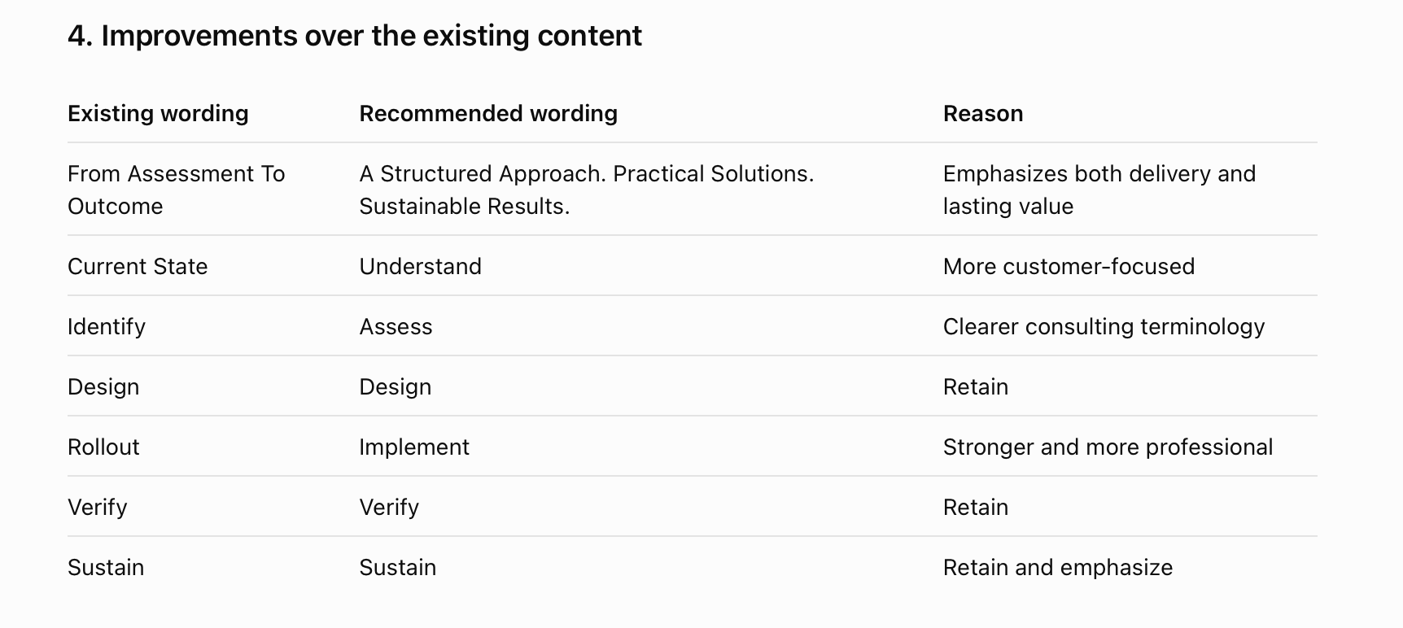
Because most consulting companies communicate that they will assess, recommend and implement. Mars Sigma can differentiate itself by emphasizing continued management-system effectiveness after implementation.
This also creates a natural connection to the Management System Sustenance service that we introduced earlier.
However, the website should not suggest that every consulting engagement automatically includes indefinite ongoing support. Sustenance can be offered as a separate, structured engagement.

A stronger closing statement

We Don't Stop at Implementation.
We help organizations establish the processes, competencies and improvement practices needed to sustain performance long after the initial engagement.
This communicates a clear business benefit without promising results that depend on factors outside Mars Sigma's control.

Section 9: Client Testimonials & Success Stories

CLIENT SUCCESS & EXPERIENCE

Trusted Expertise. Meaningful Improvements. Lasting Relationships.
At Mars Sigma Solutions, we measure the value of our work through the improvements our customers are able to implement and sustain.
From strengthening management systems and improving manufacturing processes to developing people and enhancing supplier quality, our engagements focus on addressing real business challenges.
Our Customer Success Stories
01 | Automotive Quality Management
Strengthening Systems. Improving Process Discipline.
Supporting automotive organizations in strengthening quality management practices, improving process controls and preparing for applicable IATF 16949 requirements.
02 | Manufacturing Excellence
Reducing Inefficiencies. Strengthening Performance.
Helping manufacturing organizations identify operational gaps, improve process consistency and introduce practical continual-improvement initiatives.
03 | Environmental, Health & Safety Management
Building Safer, More Responsible Operations.
Supporting organizations in implementing and improving environmental and occupational health and safety management systems aligned with applicable ISO requirements.
04 | Training & Competency Development
Developing People. Building Organizational Capability.
Delivering industry-focused training that helps professionals strengthen their understanding of management systems, auditing, quality tools and continuous improvement.

Every Business Challenge Is Different. Our Commitment to Practical Solutions Remains the Same.
Explore How Mars Sigma Can Support Your Organization.

How I recommend displaying customer success
Rather than displaying four anonymous quotations, I recommend combining two elements:
A. Verified customer testimonials
Short, authentic statements from customers who have agreed to be featured.
B. Project success stories
Brief descriptions of the customer's challenge, Mars Sigma's intervention and the documented outcome.
Here is the visual structure I would recommend.

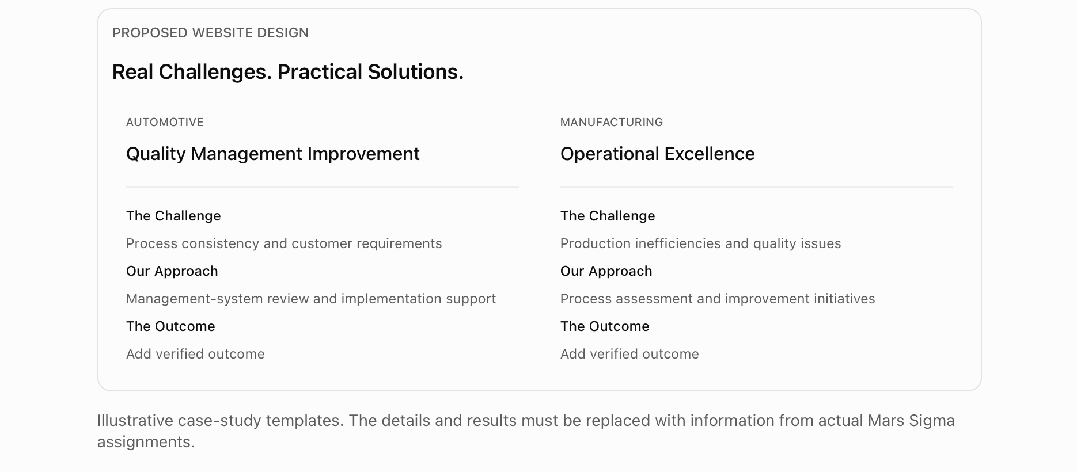

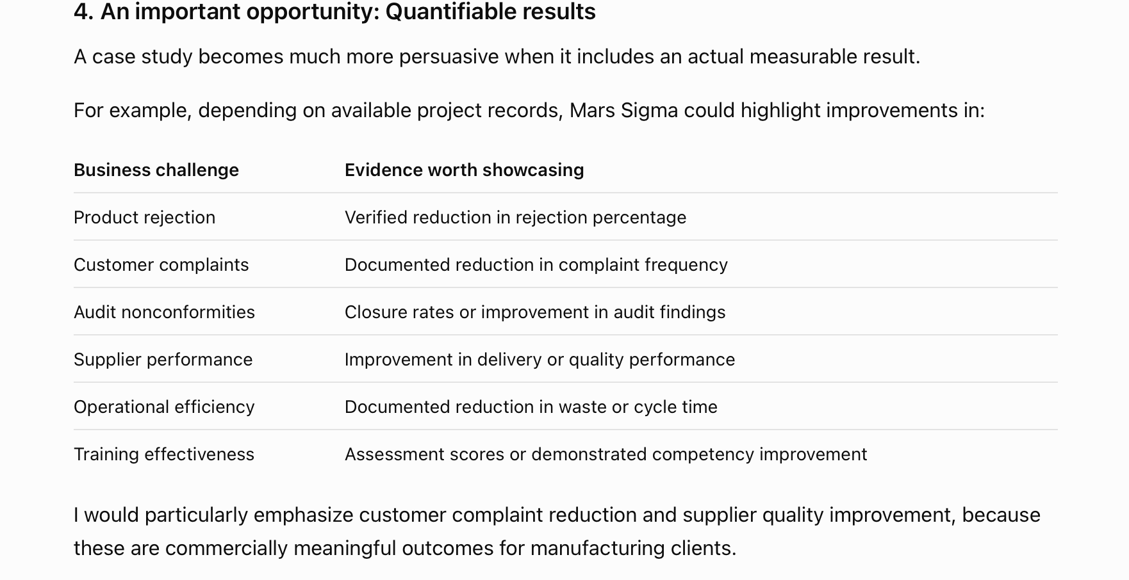

STANDARDS & FRAMEWORKS

Global Standards. Practical Expertise. Sustainable Excellence.
International standards provide the foundation for effective management systems, consistent processes and improved organizational performance.
At Mars Sigma Solutions, we help organizations understand, implement, strengthen and sustain management systems aligned with applicable international standards and industry-specific requirements.
Our approach goes beyond documentation and certification readiness to focus on practical implementation, operational effectiveness and continual improvement.

Our Areas of Expertise
ISO 9001 – Quality Management Systems
Strengthen process effectiveness, customer satisfaction, risk-based thinking and continual improvement through a robust Quality Management System.
IATF 16949 – Automotive Quality Management
Support automotive manufacturers and suppliers in strengthening quality management practices, process controls, customer-specific requirements and automotive Core Tools.
ISO 14001 – Environmental Management Systems
Establish effective environmental management practices, improve environmental performance and strengthen compliance with applicable obligations.
ISO 45001 – Occupational Health & Safety Management Systems
Develop systematic approaches to identifying workplace hazards, managing OH&S risks and improving occupational health and safety performance.
ISO/IEC 27001 – Information Security Management Systems
Strengthen information security governance, risk management and the protection of organizational information assets.
AS9100 – Aerospace Quality Management
Support aerospace organizations in establishing effective quality management practices aligned with applicable aerospace industry requirements.
ISO 22000 – Food Safety Management Systems
Strengthen food safety management through systematic hazard controls, operational practices and continual improvement.
ISO/IEC 17025 – Testing & Calibration Laboratories
Support laboratories in developing management and technical systems aligned with competence requirements and preparing for applicable accreditation assessments.

Specialized Automotive & Quality Frameworks
VDA 6.3 – Process Auditing
Support process audit preparation, supplier process evaluations and improvement activities based on automotive industry requirements.
Automotive Core Tools
APQP | PPAP | FMEA | MSA | SPC

From Standards Compliance to Operational Excellence.
Partner with Mars Sigma to build management systems that work, perform and continually improve.
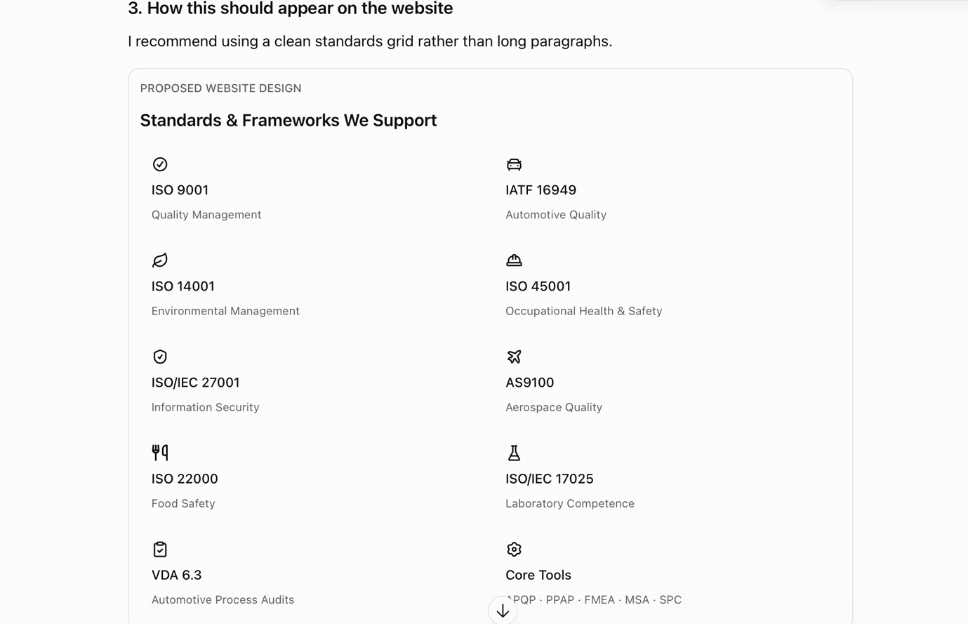

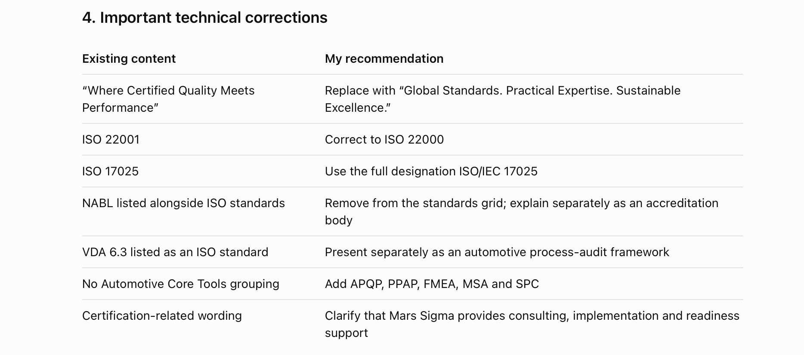

A special recommendation regarding ISO 9001:2026
Since we have already created a dedicated ISO 9001:2026 transition section, I suggest keeping the standards grid relatively timeless by displaying ISO 9001 rather than embedding an edition year in every reference.
A separate link can read:
“Preparing for ISO 9001:2026? Explore Our Transition Support.”
One important publication check: the website should not describe ISO 9001:2026 as a published replacement for ISO 9001:2015 until its official publication and applicable transition arrangements are confirmed. This distinction also applies to the earlier transition section we drafted.
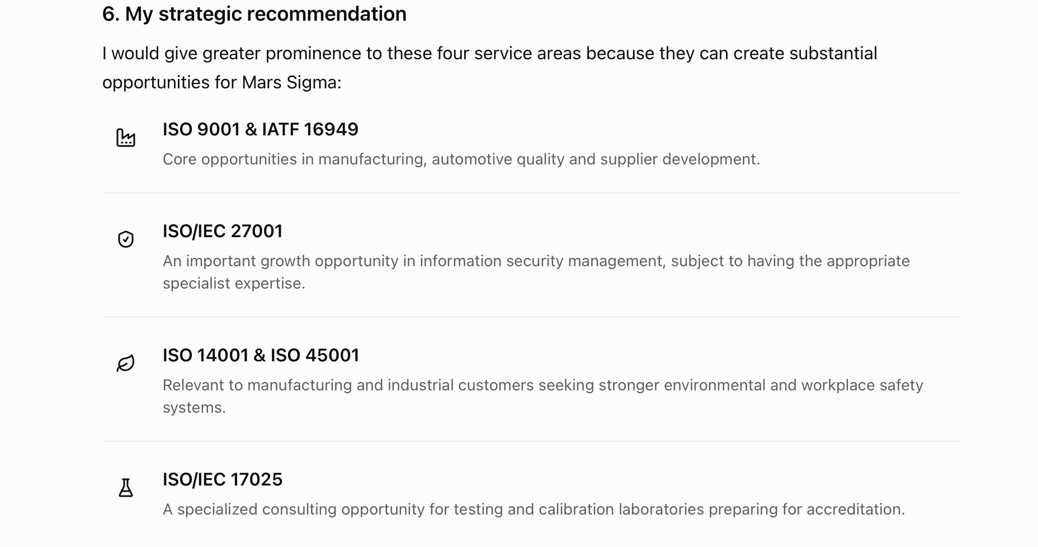

LET'S WORK TOGETHER

Your Challenges. Our Expertise. Better Business Outcomes.
Whether you are preparing for ISO certification, strengthening your management systems, improving manufacturing quality, developing suppliers or building workforce capabilities, Mars Sigma is ready to support your journey.
Our experienced professionals work closely with your organization to understand your requirements and develop practical solutions that improve performance and create sustainable value.
Let's discuss how we can help your business move forward.
Primary Button: Talk to Our Experts
Secondary Button: Request a Consultation
Supporting line:
ISO Management Systems | Business Transformation | Third-Party Inspection | Supplier Development | Industrial Training | Management System Sustenance
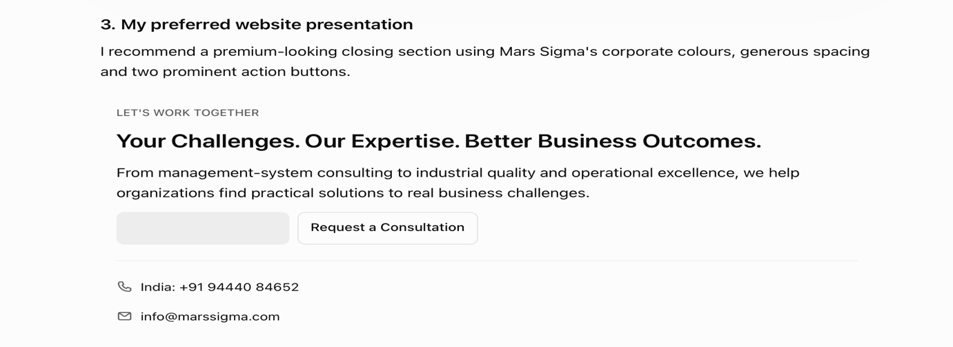
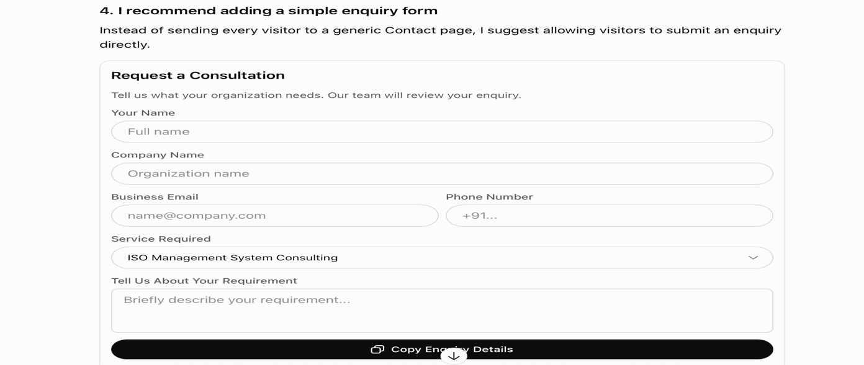

Important recommendations for generating more enquiries
Website element | My recommendation
Primary CTA | Talk to Our Experts
Secondary CTA | Request a Consultation
Contact number | Make it clickable on mobile
Email address | Link to info@marssigma.com
WhatsApp | Add a business WhatsApp option if the number is approved for enquiries
Enquiry form | Keep it short and easy to complete
Service selection | Include all six core services
Enquiry handling | Route submissions to the appropriate Mars Sigma contact
Privacy | Add a clear privacy notice and appropriate consent mechanism

Home Page – Content Review Summary
We have now developed the main Home Page sections:
- Hero Section
- Who We Are
- What We Do
- ISO 9001:2026 Transition
- Why Mars Sigma?
- Industries We Serve
- Founder Profile
- How We Work
- Client Success & Testimonials
- Standards We Work With
- Final Call to Action

